Paul M. Summitt  312 Proctor Drive  Columbia, MO 65202  573-554-8635  paulmsummitt@earthlink.net | Copyright 2020 by  Paul M. Summitt  All rights reserved  About <word count> words

Summitt Family History

From Chester Moody Summitt back to Jakob Sammet
by
Paul M. Summitt

INTRODUCTION

Chapter 1

Chester Moody Summitt (1931-2009)

Chester Moody SUMMITT was my dad. He was born on September 9, 1931, in Cardwell, Missouri. His father, Chester, was 44 and his mother, Katie, was 40.
On Aug 23, 1934, when Moody, as he was came to be known, was 2 years old, his sister Alice Lucretia was born. Alice Lucretia died a year later on February 9, 1935, in Cardwell, Missouri, when he was 3 years old.
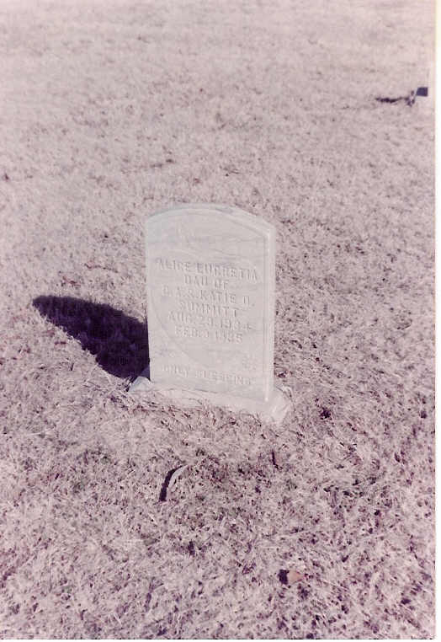Photograph 1: Alice Lucretia Summitt tombstone

1940
Age 9

Chester A Summitt - 1940 Census
1940 Census
- 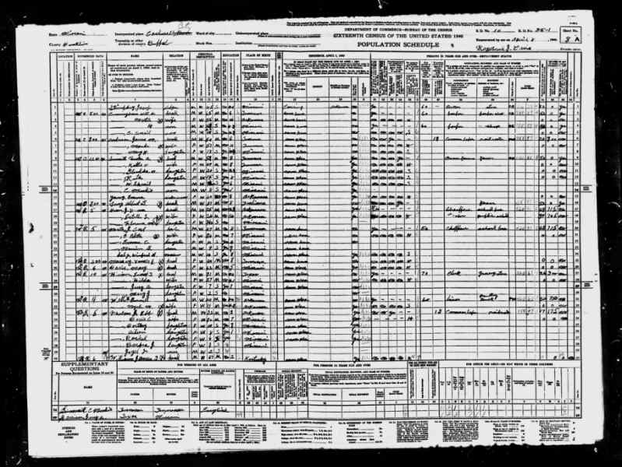

1940
- 8 Dec

1941
Age 10
Review

The United States enters World War II
Chester Moody SUMMITT lived in Cardwell, Missouri, when the United States declared war on Japan just one day after the attack on Pearl Harbor that killed 2,400 Americans.
- 
- 12 Apr

1945
Age 13
Review

First Inauguration of Harry S. Truman
Chester Moody SUMMITT of Cardwell, Missouri, was likely shocked when Harry S. Truman suddenly became president of the United States in 1945.
- 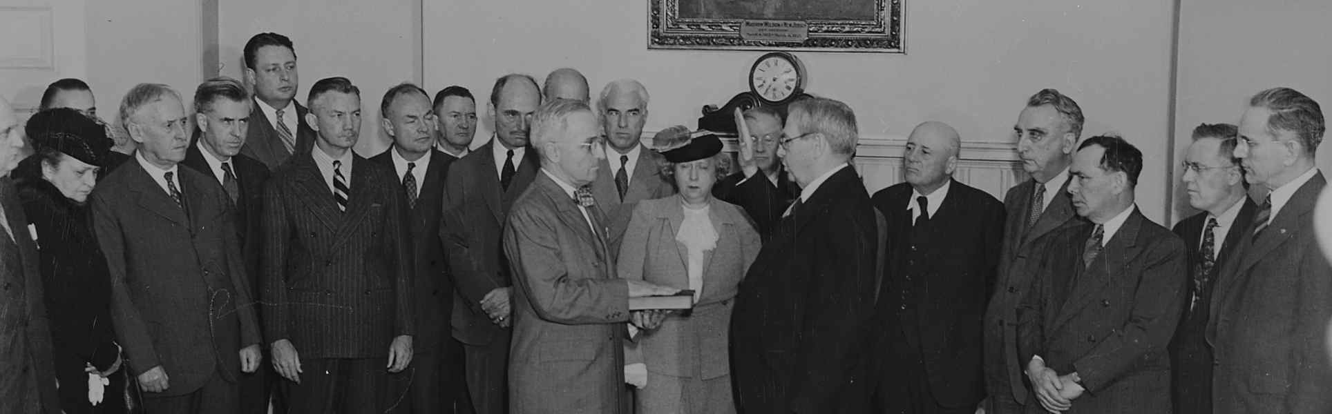
- 14 Sep

1950
Age 19

Marriage
Chester Moody SUMMITT married Shirley Francis Hill in Arkansas on September 14, 1950, when he was 19 years old.
- 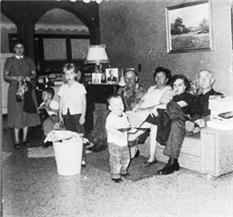

Shirley Francis Hill
1934–2012

14 Sep 1950 • Arkansas, United States
- 14 Sep

1950
Age 19

Marriage
Chester Moody SUMMITT was married in Arkansas on September 14, 1950, when he was 19 years old.

14 Sep 1950 • Arkansas, United States
- abt

1950
Age 19

Chester Moody Summitt
- 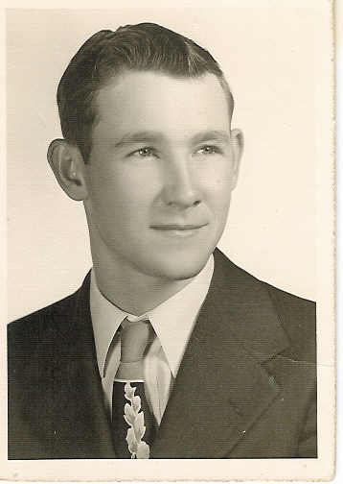

abt 1950

1950
Age 19

Cardwell Senior Class of 1950
- 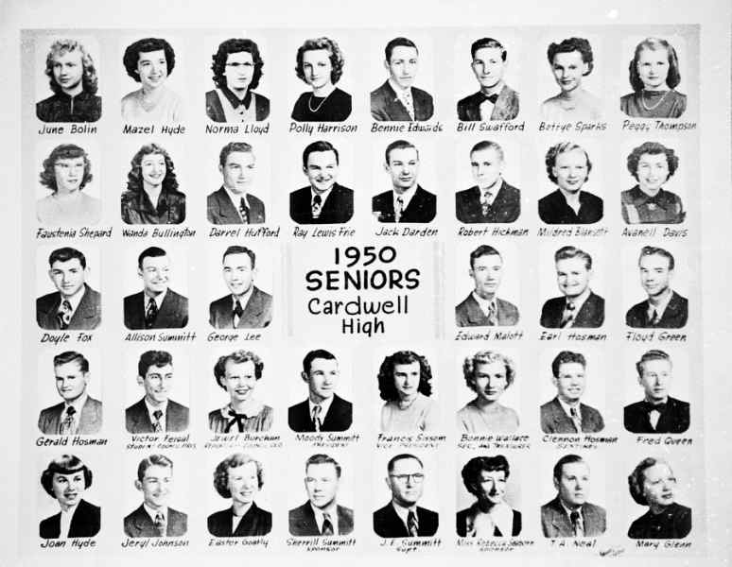

1950
- abt

1951
Age 20

Chester Moody Summitt
- 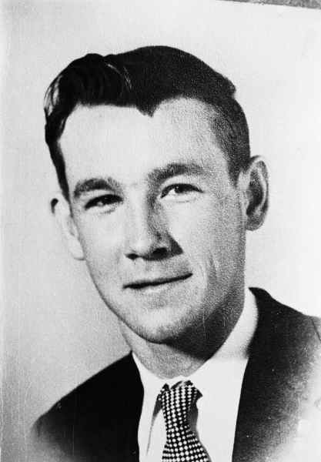

abt 1951
- abt

1952
Age 21

Chester Moody Summitt and Shirley Francis Frie Summitt
- 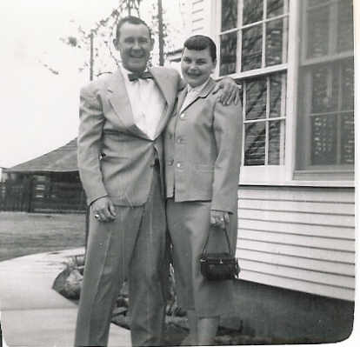

abt 1952
- abt

1952
Age 21

Chester Alba Summitt and Chester Moody Summitt
- 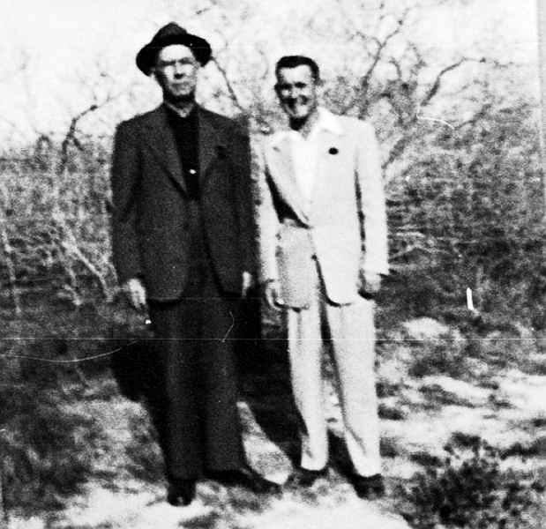

abt 1952
- 21 Oct

1953
Age 22

Death of Mother
His mother Katie Okalona passed away on October 21, 1953, in Memphis, Tennessee, at the age of 63.
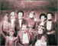

Katie Okalona DARDEN
1890–1953

21 Oct 1953 • Memphis, Shelby, Tennessee, United States
- abt

1953
Age 22

Shirley Francis Frie Summitt and Chester Moody Summitt
- 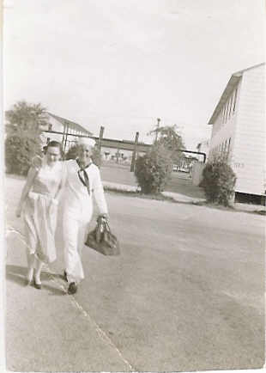

abt 1953
- abt

1953
Age 22

Chester Moody Summitt's Naval Unit at Kingsville Naval Air Station abt 1953
- 

abt 1953
- abt

1953
Age 22

Herbert, Papa, & Dad
(left to right) Herbert Allison Summitt, Chester Alba Summitt, and Chester Moody Summitt
- 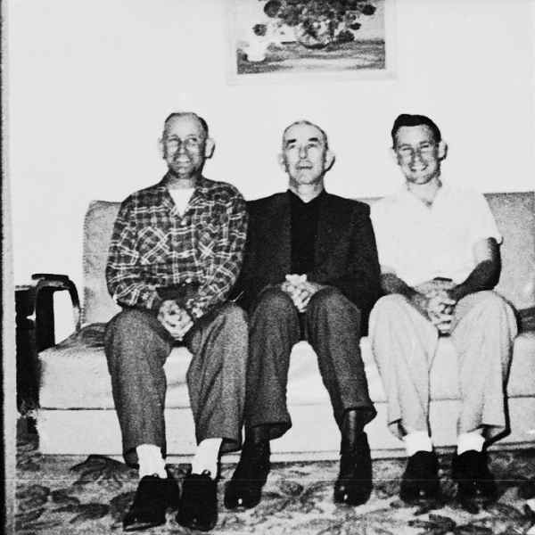

abt 1953
- abt

1953
Age 22

Herbert, Papa, & Dad
(left to right) Herbert Allison Summitt, Chester Alba Summitt, and Chester Moody Summitt
- 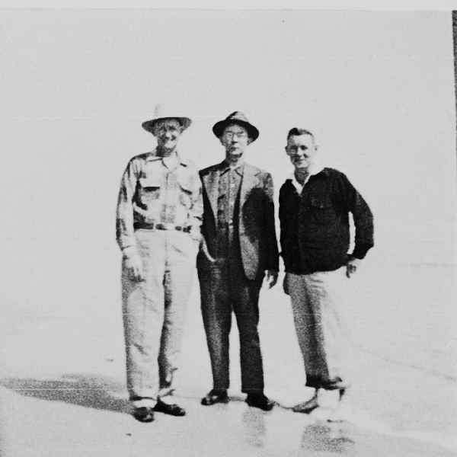

abt 1953
- 7 Apr

1954
Age 22

Birth of Son
His son Paul Moody was born on April 7, 1954, in Kingsville, Texas.


Paul Moody Summitt
1954–

07Apr1954 • Kingsville, Kleberg County, Texas, USA
- Apr

1954
Age 22

Paul Moody Summitt, Chester Alba Summitt, and Chester Moody Summitt
- 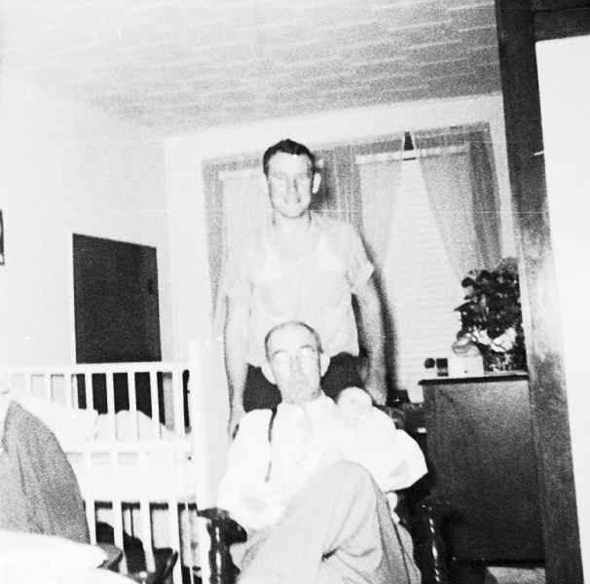

abt April 1954
- abt

1954
Age 23

Chester Moody Summitt & Shirley Francis (Frie) Summitt
This photo taken shortly before I was born in April 1954. I think it may have been a Christmas picture taken and sent home to Missouri to the family.
- 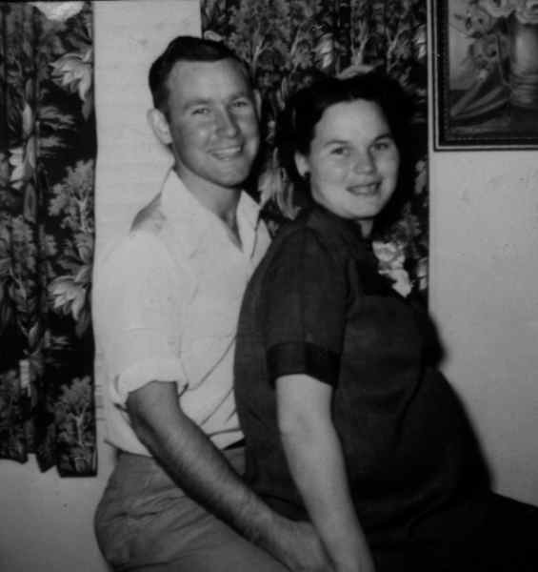

abt 1954
- abt

1954
Age 23

Drayton Martin, Dorthy Martin, and Chester Moody Summitt
- 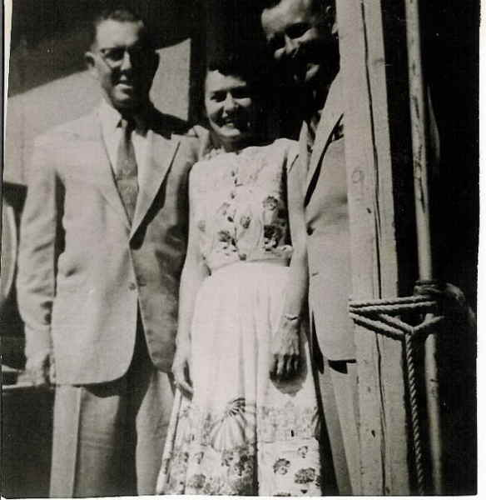

abt 1954
- abt

1954
Age 23

Chester Moody Summitt and Paul Moody Summitt
- 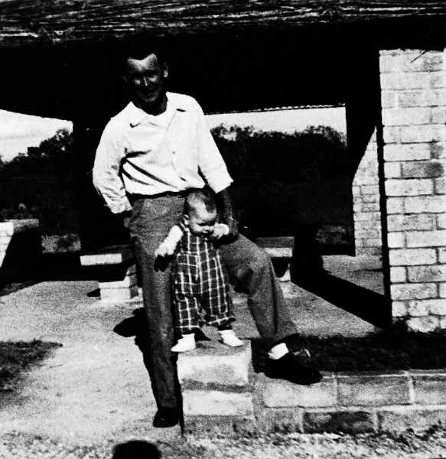

abt 1954

1954
Age 23

Chester Moody Summitt and Paul Moody Summitt
- 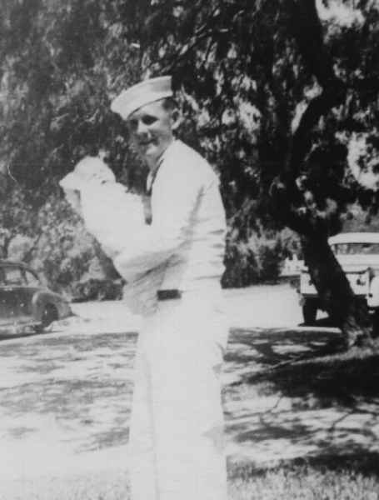

1954

1954
Age 23

Paul Moody Summitt and Chester Moody Summitt
- 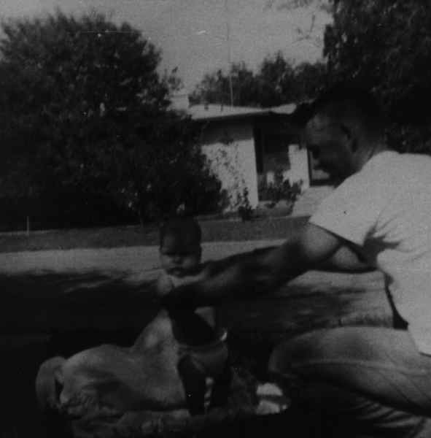

1954
- abt

1955
Age 24

Shirley Francis Frie Summitt, Chester Moody Summitt, and Paul Moody Summitt
- 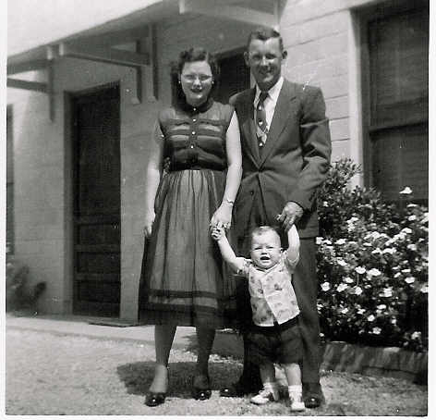

abt 1955
- abt

1955
Age 24

Chester Moody Summitt and Paul Moody Summitt
- 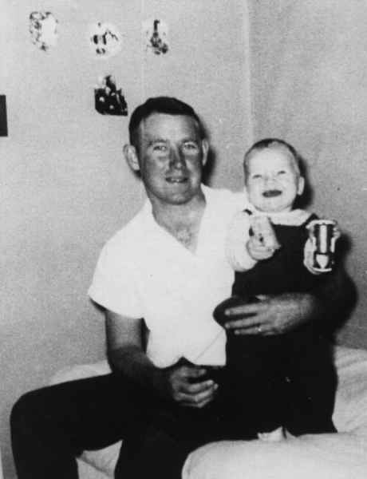

abt 1955
- abt

1957
Age 26

"Papa Blackie" Blackburn, Paul Moody Summitt, Shirley Francis Frie Summitt, and Chester Moody Summitt
- 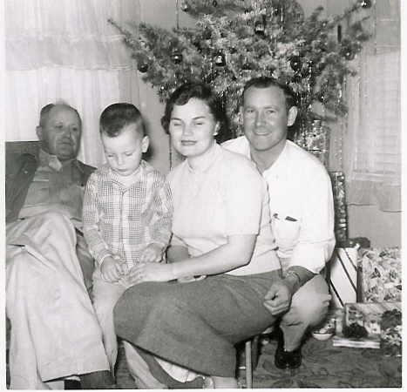

abt 1957
- abt

1957
Age 26

Sam Martin, Chester Moody Summitt, Drayton Martin, Paul Moody Summitt
- 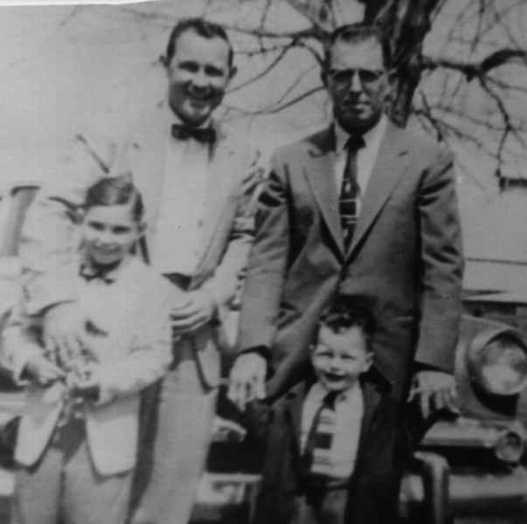

abt 1957

1958
Age 27

Residence
Chester Moody SUMMITT lived in Columbia, Missouri, in 1958.
U.S. City Directories, 1822-1995

1958 • Columbia (Boone) Missouri USA
- abt

1958
Age 27

Chester Moody Summitt and Paul Moody Summitt
- 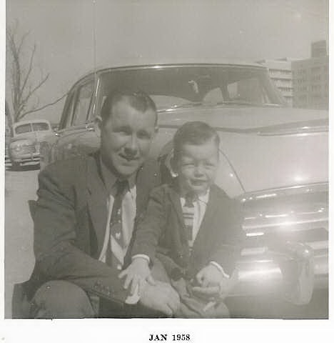

abt 1958
- abt

1958
Age 27

Chester Moody Summitt and Paul Moody Summitt
- 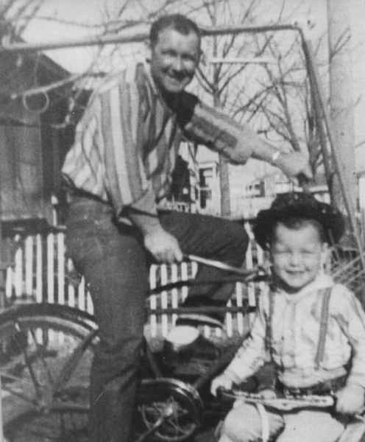

abt 1958
- 31 Dec

1959
Age 28

Birth of Son
His son Bruce Allen was born on December 31, 1959, in Poplar Bluff, Missouri.


Bruce Allen Summitt
1959–

31Dec1959 • Poplar Bluff, Missouri, USA

1960
Age 29

Residence
Chester Moody SUMMITT lived in Poplar Bluff, Missouri, in 1960.

1960 • Poplar Bluff, Missouri, USA
- Jul

1967
Age 35

Bruce Allen Summitt, Chester Moody Summitt and Paul Moody Summitt
- 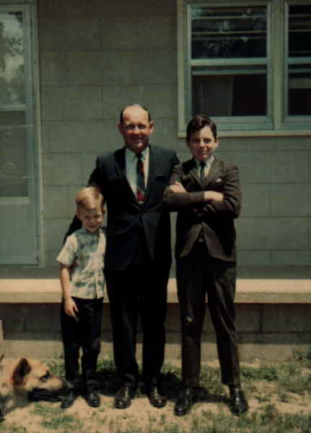

Jul 1967
- Jul

1967
Age 35

Chester Moody Summitt & Shirley Francis (Frie) Summitt
- 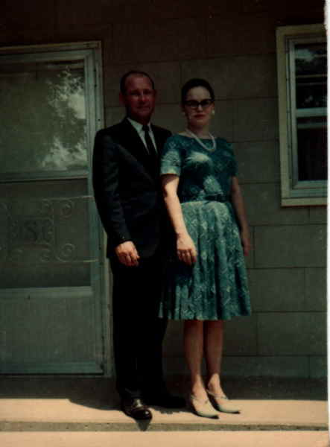

July 1967

1967
Age 36

Chester Moody Summitt at Hornets Nest Monument Shiloh 1967
- 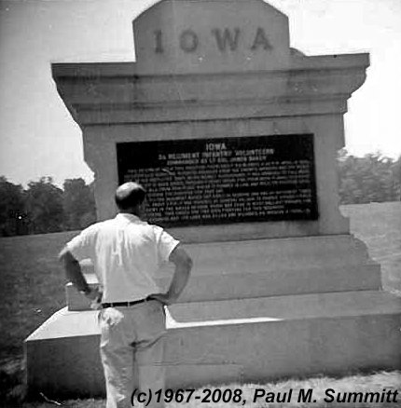

1967
- 10 Mar

1970
Age 38

Death of Father
His father Chester Alba passed away on March 10, 1970, in Memphis, Tennessee, at the age of 83.


Chester Alba SUMMITT
1887–1970

10 Mar 1970 • Memphis, Shelby County, Tennessee
- abt

1970
Age 39

Chester Moody Summitt Family with Dessie Blackburn
- 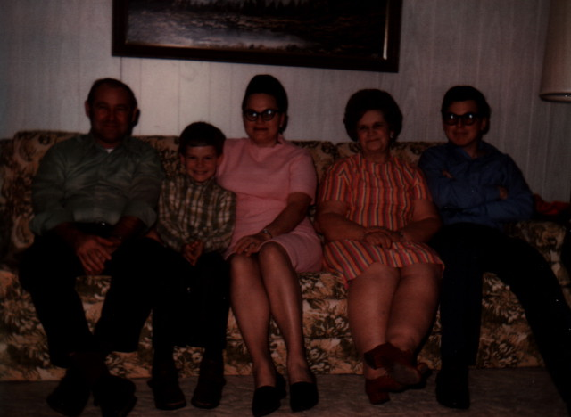

abt 1970
- abt

1973
Age 42

Shirley Francis Frie Summitt and Chester Moody Summitt
- 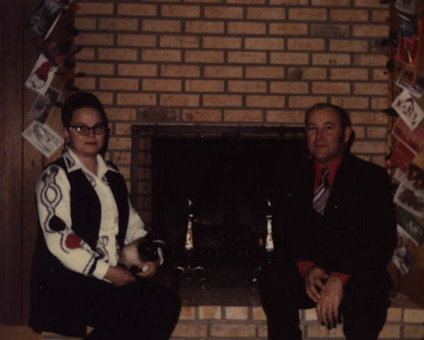

abt 1973
- 4 Nov

1974
Age 43

Death of Brother
His brother Herbert Allison died on November 4, 1974, in Jonesboro, Arkansas, when Chester Moody was 43 years old.


Herbert Allison SUMMITT
1912–1974

4 Nov 1974 • Jonesboro, Craighead, Arkansas, United States
- abt

1975
Age 44

Divorce
Chester Moody SUMMITT and Shirley Francis Hill were divorced in 1975 after 25 years of marriage. He was 44 years old.
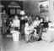

Shirley Francis Hill
1934–2012

abt 1975
- abt

1975
Age 44

Shirley Francis Frie Summitt and Chester Moody Summitt
- 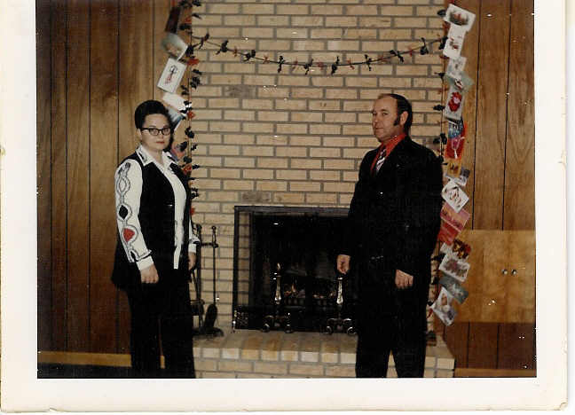

abt 1975

1977
Age 46

Chester Moody Summitt & Paul Moody Summitt 1977
- 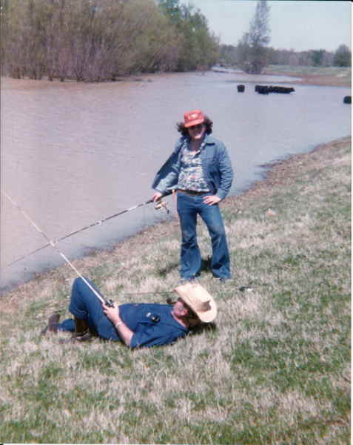

1977
- abt

1978
Age 47

Chester Moody Summitt
- 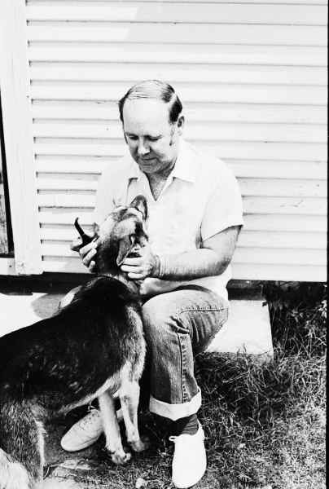

abt 1978
- abt

1978
Age 47

Dawn Lynn Mick Summitt and Chester Moody Summitt
- 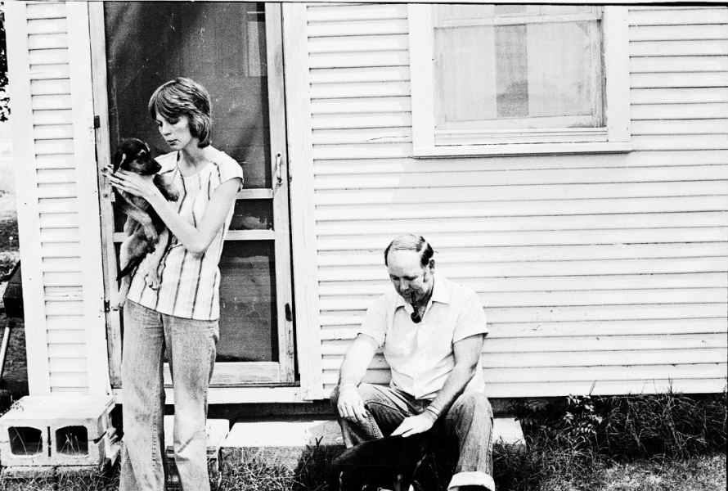

abt 1978
- abt

1978
Age 47

Chester Moody Summitt
- 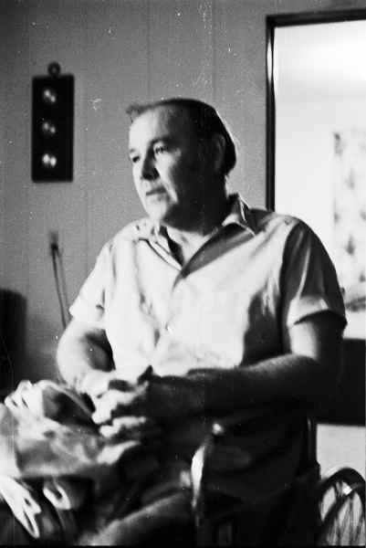

abt 1978
- Aug

1979
Age 47

Chester Moody Summitt, Paul Moody Summitt, and Paul Michael Summitt
- 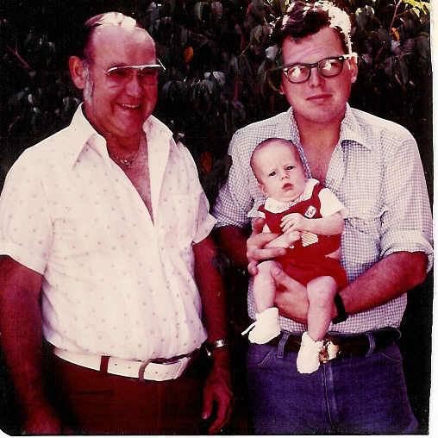

Aug 1979

1979
Age 48

Residence
Chester Moody SUMMITT lived in Cardwell, Missouri, in 1979.

1979 • Cardwell, Missouri, USA

1979
Age 48

Chester Moody Summitt & Dawn Lynn Mick Summitt & Paul Michael Summitt & Earl Holcomb
- 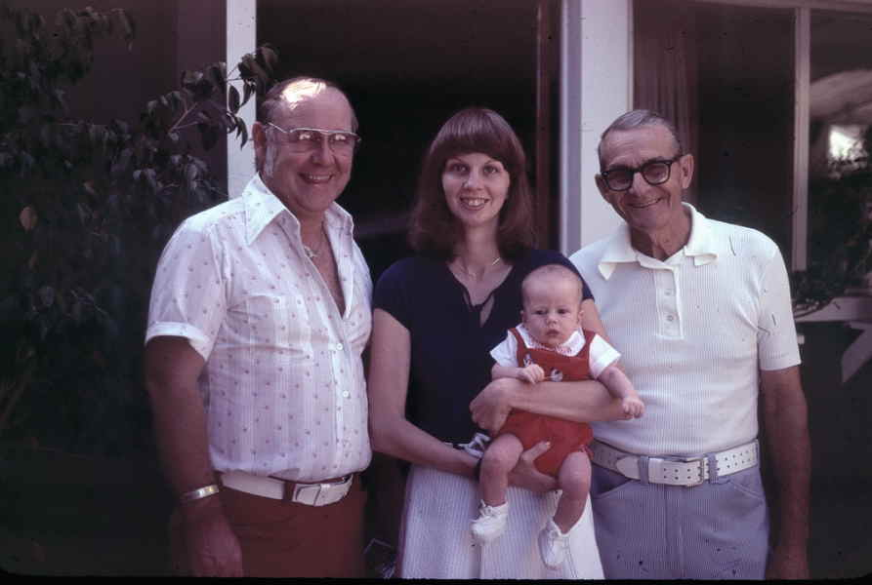

1979
- abt

1980
Age 49

Chester Moody Summitt and Paul Michael Summitt
- 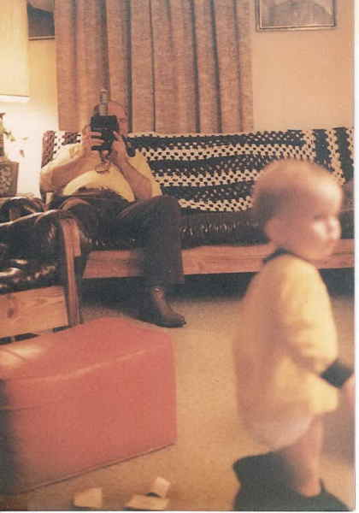

abt 1980
- abt

1980
Age 49

Chester Moody Summitt
- 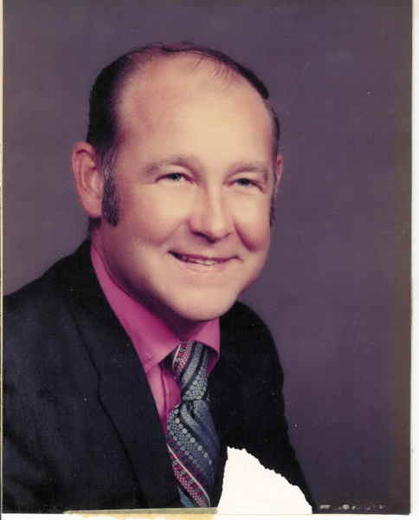

abt 1980

1985
Age 54

Chester Moody Summitt
- 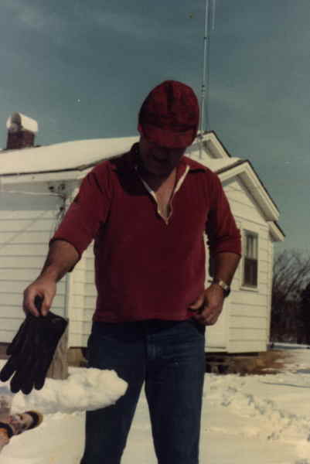

1985
- 13 May

1989
Age 57

Marriage
Chester Moody SUMMITT was married in Campbell, Missouri, on May 13, 1989, when he was 57 years old.

05/13/1989 • Campbell, Missouri
- 15 Jun

1989
Age 57

Death of Brother
His brother William Sherrill died on June 15, 1989, in Stoddard, Missouri, when Chester Moody was 57 years old.
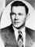

William Sherrill SUMMITT
1927–1989

15 Jun 1989 • Stoddard County, Missouri, USA
- Age 67

Residence
Chester Moody SUMMITT lived in Cardwell, Missouri.

1998 1999 2000 2001 2002 • Cardwell, Missouri

2004
Age 73

Paul Moody Summitt, Chester Moody Summitt, and Bruce Allen Summitt
- 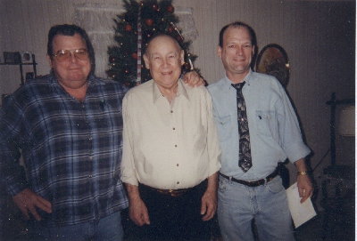

2004
- abt

2007
Age 76

Wilma Jean Cooper Summitt and Chester Moody Summitt
- 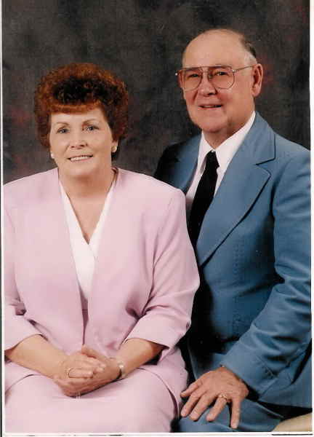

abt 2007
- Apr

2009
Age 77

Dad
- 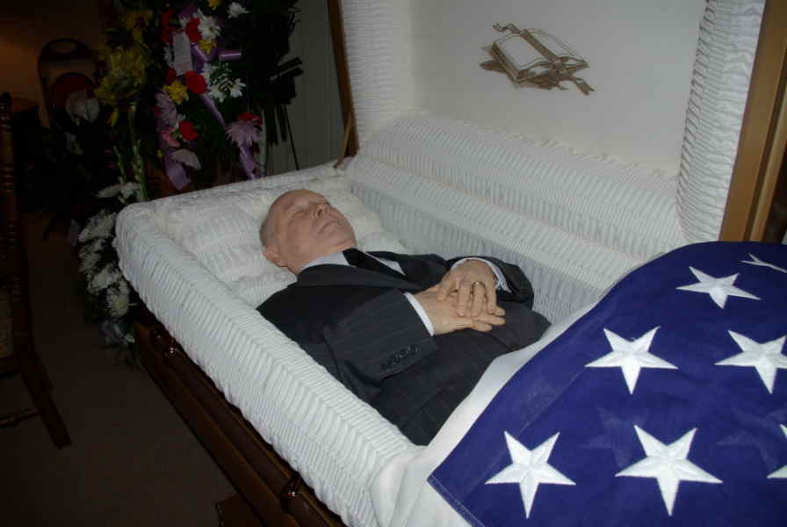

April 2009
- 27 Apr

2009
Age 77

Death
Chester Moody SUMMITT died on April 27, 2009, in Paragould, Arkansas, when he was 77 years old.

27 Apr 2009 • Paragould, Greene County, Arkansas

Burial

Cardwell, Dunklin County, Missouri, USA

